REFLECTIONS ON THE PASSING OF ABHC ‘FOUNDING FATHER’ - CHRIS WEBB
1939 – 2021

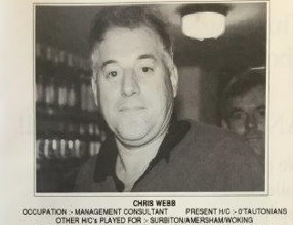
Australia 1989
Co-Founder
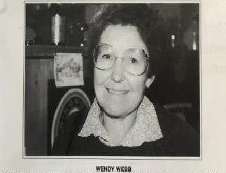
Australia 1989
Wendy Webb
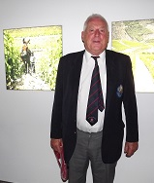
Chris Webb
Portugal 2015
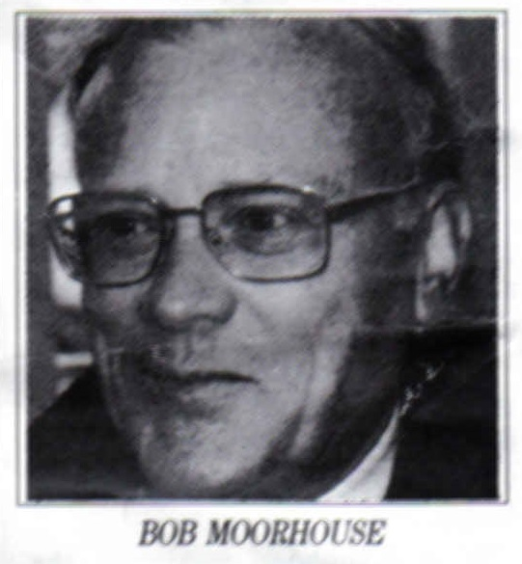
Bob Moorhouse
Co-Founder

Chris, was one of the two ‘Founding Fathers’, of the Ancient Britons HC – the other being Bob Moorhouse, who sadly passed away unexpectedly in 2005 at the age of 70.
It would be difficult to imagine two more dissimilar people getting together to form a sporting Club. Bob, a medium height, red-headed, slim, meticulous, inventive mechanical engineer of welcoming smile but precise, clipped sentences and Chris, a business consultant of impressive stature in the ‘brick outhouse’, mould with suitably expansive personality and authoritative air generating bonhomie!!
But the chemistry between the two worked and from their discussions which began in the mid-1980’s – and with important input from the ladies – the AB formula for senior veteran hockey Touring was developed which led to the first AB Tour in 1989 with Bob as organising ‘Fuhrer’, Chris as ‘Skip’, and wife Wendy as ‘Boss Woman’!!
Interestingly, at that point, the AB Club was the only group of Senior Veteran hockey players gathered specifically for the purpose of Touring. Individual Clubs and Festival sides of mixed ages had indeed embarked on overseas tours before then, but it would be 1995 before that bastion of Senior Veterans hockey - the LX Club – would come into being.
The ‘raison d’etre’, for the establishment of the AB and LX Clubs is an interesting comparison:-
AB – Every two years or so, senior veteran Players and Partners would be invited to join in a Tour to exotic, distant sunny climes; these Tours would be in the form of a holiday which would include a number of serious competitive hockey matches followed by equally serious ‘apres-match’, conviviality. The ladies were much enamoured of this prospect, gave their support and embraced the idea wholeheartedly – even to the extent of offering to cheer wildly from the touchline!
LX – To provide a vehicle to select the best players of over-60 years of age to compete in matches and tournaments of a national representative nature with similar teams from other countries and to develop fixtures with other super-veteran teams in the UK.
There is therefore no inherent conflict of interest between the two Clubs and Senior Veteran players can – and do – join both Clubs without any qualms of conscience but rather with the attraction of a choice of enjoyable hockey.

BUT BACK TO CHRIS :
As inaugural AB ‘Skip’, it was down to Chris to set the standard for those following and he certainly did that. A combination of ‘presence’, emphasised by physical stature and ‘hospitable geniality’, camouflaged an authoritarian ‘Nelsonic’ undertone (viz. England expects…….etc.), that emerged on the field of play.
On the run-up to the first AB Tour in 1989, Skip and Boss Woman hosted a number of most enjoyable ‘get-togethers’, (‘team bonding’, as we know it), at their Woking home ‘April Embers’. During these, Chris introduced the idea of ‘the juggable offence’ – any perceived indiscretion (real or ‘fabricated’), to be discharged by the purchase of a jug of ale! On Tour, Chris was in his element as leader of the post-match socialising pack and once he had established his position at the Bar, he would dispense wit and tales of ‘derring-do’, to the delight and entertainment of our hosts. Coincidentally in 1989, AB Touring had, in Chris, produced its own w.w.w. - in parallel with that of Tim Berners-Lee!
His sporting interests revolved around cricket, hockey and golf – where he had a single-figure handicap. He was, however, custom-designed for grass (particularly muddy grass!), hockey pitches!! Tall, set square, on the ‘laid-back’ end of casual BUT with long levers, an English stick, a crunching tackle and a fierce strike he read the game well and was always about in defence guarding the circle with “Churchillian” resolve – often identified by a short-sleeve cricket sweater worn over his playing shirt.
If the above attributes proved insufficient to foil attacking forwards there was always the secret weapon – a hip action which even ‘Strictly’s’ Craig Revel Horwood would applaud. Over the years, in Bournemouth’s Easter Festival, my own Walsall Club often found itself up against Chris and his Old Tauntonian mercenaries; for most of those years, Walsall’s nippy and usually prolific ‘Greavsie-style’, centre forward rarely got a shot on goal; it was difficult from a prone position!!

Several current ABs met up with Chris & Wendy at Taylors (Port) Cellar Restaurant on our Portugal Tour 2015 (see above).
Perhaps the final words should be from John Carrick – a fellow Tourer with Chris on that 1989 Tour of the Antipodes:
“Chris was my Captain on this first AB Tour and he was held in high regard by all who knew him!
He was a true tourer! Played hard, drank hard and partied hard. But at the same time, was always respectful to his opponents on and off the pitch”.
